|  |  |  |  |
| --- | --- | --- | --- |
| 1 | | 66,854.42857142857 | |
| NUMERO DE FRONTERAS | | ENERGIA AGREGADA | |
|  | | | |
| SI | | 26-10-2020 | |
| CONTRATO | | VENCIMIENTO CONTRATO | |
|  | | | |
| 231,576,339 | 150 | | 8,853,001 |
| INGRESO 2019 | DÍAS CERTIFICADOS 2019 | | ENERGIA RESPALDADA 2019 |
|  | | | |
| 292,789,602 | 203 | | 10,997,188 |
| INGRESO 2020 | DÍAS CERTIFICADOS 2020 | | ENERGIA RESPALDADA 2020 |
|  | | | |
| 149,747,039 | 94 | | 6,488,751 |
| INGRESO 2021 | DÍAS CERTIFICADOS 2021 | | ENERGIA RESPALDADA 2021 |

|  |
| --- |
| **CERAMICA ITALIA**  USUARIO |

|  |
| --- |
| **Mateo Porras**  Ejecutivo de cuenta |

|  |
| --- |
| **Euler Saavedra / Director de Innovación Tecnológica / 3163507793**  PUNTO FOCAL |

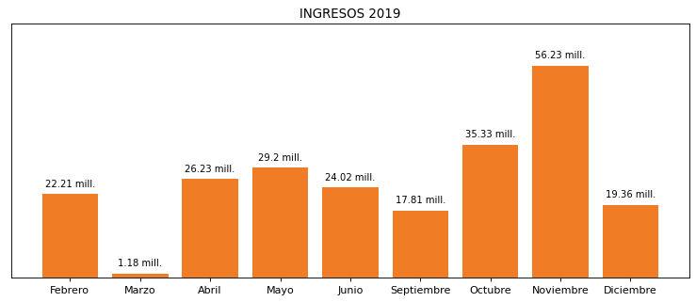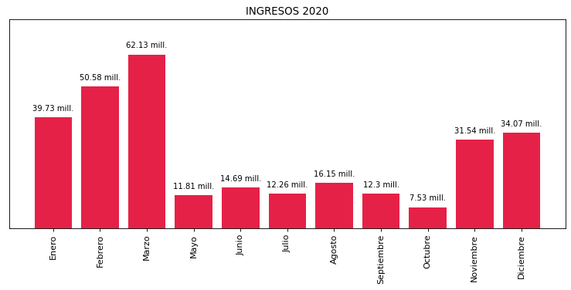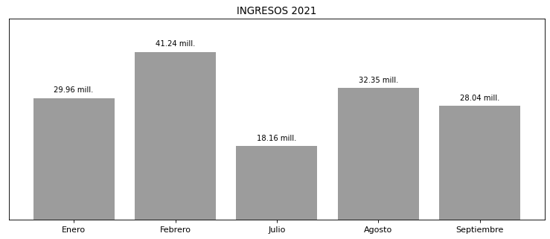

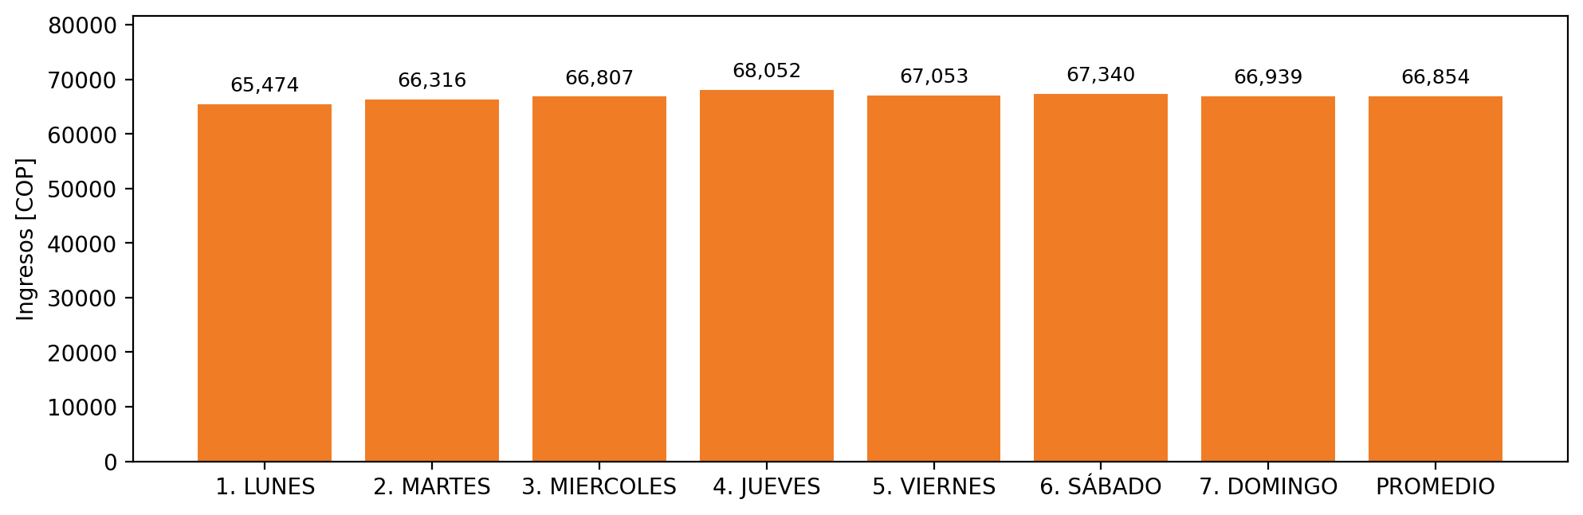

|  |  |  |  |  |  |  |  |  |  |  |
| --- | --- | --- | --- | --- | --- | --- | --- | --- | --- | --- |
| **FRONTERA** | **COD SIC** | **PREDIO** | **FRT DDV** | **TIPO DDV** | **PROMEDIO** | **PRÓXIMA ACTUALIZACIÓN** | **MARGEN DE ERROR** | **ÚLTIMA PRUEBA DDV** | **DÍAS PARTICIPACIÓN** | **FECHA REFERENCIA PRÓXIMA PRUEBA DDV** |
| CERAMICA ITALIA | Frt10371 | Prd01119 | Frt31451 | LBC | 66,854 | 2022-02-25 | 1,82 | 2021-07-01 | 50.0 | 2021-12-14 |